# PeopleSafe - Shipment Tracking by Carrier Website

Reminders

Process

 USPS

USPS Tracking Issue

 UPS

 FedEx

Related Documents

**Description:** Process for locating tracking information on the USPS, UPS, and FedEx website

|  |
| --- |
| Reminders |

PeopleSafe will include a link on the Main Screen that will allow CCRs to view tracking information for packages sent from the mail pharmacy. It may take up to 48 hours for tracking information to be updated on the carrier’s websites. There is an alternative way to access this information directly from the USPS website as well.

 If a caller asks for an estimated delivery timeframe, advise that any delivery times listed are estimates only and provide estimated delivery shown on carrier’s website. If no delivery estimate is listed, advise caller as such, and remind member that delivery times can vary based on current weather and shipping conditions.

Top of the Document

|  |
| --- |
| Process |

Perform the steps below:

|  |  |  |
| --- | --- | --- |
| **Step** | **Action** | |
| **1** | Locate the order on the Main Screen and double click on the tracking number, which should open a pop-up for the tracking information.   * If the link does not work, record the tracking number for the shipment, take note of the shipping provider, and then proceed to step 2. | |
| **2** | Determine the carrier for the order. | |
| **If…** | **Then…** |
| USPS | Proceed to USPS. |
| Mail Innovations / UPS | Proceed to UPS. |
| FedEx | Proceed to FedEx. |

Top of the Document

|  |
| --- |
| USPS |

Perform the steps below:

|  |  |
| --- | --- |
| **Step** | **Action** |
| **1** | Access the USPS website: [www.usps.com](http://www.usps.com). |
| **2** | Enter the tracking number in the box directly under the **Search or Track Packages** heading on the left as shown below.    **Note:** Up to 35 tracking numbers can be entered at the same time, separated by commas. |
| **3** | Click the **Track Package** icon  to submit your query.  **Result:**  Tracking information will display for the numbers provided.   * If the tracking number does not display information or the USPS tracking does not display any information, provide the member with the tracking number and USPS Customer Service phone number provided on their website. * There are additional USPS tools for members available thru USPS.com. Members can enroll for tracking information on their order thru USPS. Members can also send an email thru USPS.com to address all LIT (Lost In Transit) issues. Once submitted, resolution is typically within 24-48 hrs. |

Top of the Document

|  |
| --- |
| USPS Tracking Issue |

USPS purges data from a tracking number at various times depending on the shipping method. Therefore, we may run into situations that when we track a package it may appear to have already been delivered on a past date. This will only occur when the new package is in pre-shipment status.

Once the new package enters the postal stream the tracking information will update and override the old information. In these situations, inform the member to allow 24 hours for the tracking number to update.

USPS purges the data from a tracking #as follows:

|  |  |
| --- | --- |
| **Type** | **When** |
| Non-Sig Packages | 120 days |
| Signature Confirmation | Up to 1 year |
| Priority Mail Express | Up to 2 years |
| Adult Signature | Up to 2 years |

**Example:** Prior Shipment

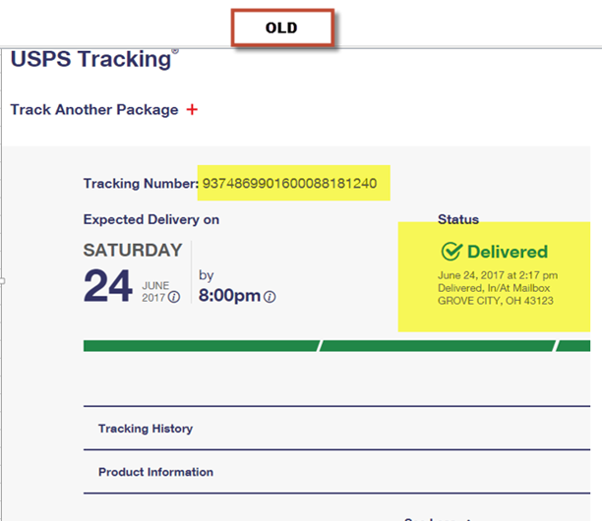

**Example:** New Shipment

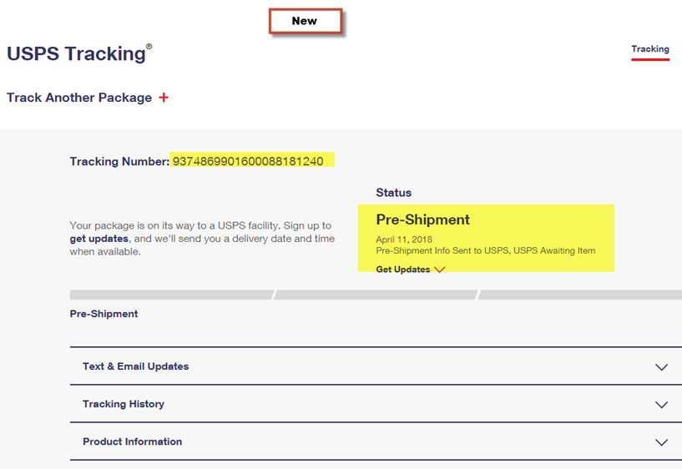

Top of the Document

|  |
| --- |
| UPS |

**Member:** To view detailed tracking information, the user must now create an account and sign in to UPS.com with a username and password or they will need to call UPS directly. Users without this login will only be able to obtain limited information as it provides the point of shipment and the point of the final UPS center.

Perform the steps below:

|  |  |
| --- | --- |
| **Step** | **Action** |
| **1** | Access the UPS website at: [www.ups.com](http://www.ups.com) and login using the following credentials. (Do not share this information with callers).   * Username: caremark.qvm1 * Password: Caremark1   **Note:** Multiple users can be logged in at the same time using the same credentials. |
| **2** | Clickon the **United States – English** area location.  **Note:** Once you have performed this on your desktop, this page does not display again going into the UPS website. |
| **3** | **Enter** tracking number inside the box directly under the **Track** option on the left side of the screen shown below.    **Note:** Up to 25 tracking numbers can be entered at the same time, separated by commas. |
| **4** | **Click** the forward arrow to display tracking results.  **Result:**  Tracking information displays for the numbers provided.   * If the tracking number does not display information or the UPS tracking does not display any information; contact UPS Customer Service at the number provided on their website. |

Top of the Document

|  |
| --- |
| FedEx |

Perform the steps below:

|  |  |
| --- | --- |
| **Step** | **Action** |
| **1** | Access the FedEx website at: [www.fedex.com/us/](http://www.fedex.com/us/). |
| **2** | Add the tracking ID in the box provided at the orange TRACK button in the center of the page & hit the orange TRACK button.  **Note:** Up to 30 tracking numbers can be entered at the same time, separated by commas.    **Result:**  Tracking information will display for the numbers provided.   * If the tracking number does not display information or the FedEx tracking does not display any information; contact FedEx Customer Service at the number provided on their website. |

Top of the Document

|  |
| --- |
| Related Documents |

[Customer Care Abbreviations, Definitions and Terms (017428)](https://thesource.cvshealth.com/nuxeo/thesource/#!/view?docid=c1f1028b-e42c-4b4f-a4cf-cc0b42c91606)

**Parent Document:** [CALL 0049 Customer Care Internal and External Call Handling](https://policy.corp.cvscaremark.com/pnp/faces/DocRenderer?documentId=CALL-0049)

Top of the Document

Not to Be Reproduced or Disclosed to Others without Prior Written Approval

**ELECTRONIC DATA = OFFICIAL VERSION / PAPER COPY = INFORMATIONAL ONLY**